OSCN LAB – 8
Name: SARA NAUSHEEN Roll No. : 2503B05138
_____________________________________________________________________________________
Q1. A process is a program in execution. In real CPU scheduling, processes do not always arrive at the same time.
The First Come First Serve (FCFS) algorithm schedules processes in order of arrival time.
Requirements:
- The program should accept:
i. Number of processes
ii. Arrival Time (AT)
iii. Burst Time (BT)
- The program must sort the processes in ascending order of arrival time.
- The CPU may become idle if the next process arrives later. Your logic must correctly handle idle time.
- Calculate for each process:
  - Completion Time (CT)
  - Turnaround Time (TAT = CT – AT)
  - Waiting Time (WT = TAT – BT)
- Display the result in a formatted table and print:
  - Total TAT and WT
  - Average TAT and WT
- Use non-preemptive FCFS.
Given System State
Consider the following processes:
Process | Arrival Time | CPU Burst Time
P1 | 2 | 4
P2 | 1 | 3
P3 | 0 | 1
P4 | 3 | 2

Program:
#include <iostream>
#include <vector>
#include <algorithm>
using namespace std;

struct Process {
string pid;
int at, bt; // Arrival Time, Burst Time
int ct, tat, wt; // Completion Time, Turnaround Time, Waiting Time
};

int main() {
int n;

cout << "Enter number of processes: ";
cin >> n;

vector<Process> p(n);

for (int i = 0; i < n; i++) {
cout << "Enter Process ID, Arrival Time & Burst Time: ";
cin >> p[i].pid >> p[i].at >> p[i].bt;
}

// Sort by Arrival Time
sort(p.begin(), p.end(), [](Process a, Process b) {
return a.at < b.at;
});

int current_time = 0;
float total_tat = 0, total_wt = 0;

for (int i = 0; i < n; i++) {

// If CPU is idle
if (current_time < p[i].at)
current_time = p[i].at;

// Completion Time
p[i].ct = current_time + p[i].bt;

// Update current time
current_time = p[i].ct;

// Turnaround Time = CT - AT
p[i].tat = p[i].ct - p[i].at;

// Waiting Time = TAT - BT
p[i].wt = p[i].tat - p[i].bt;

total_tat += p[i].tat;
total_wt += p[i].wt;
}

// Display Table
cout << "\n-----------------------------------------------------------\n";
cout << "PID\tAT\tBT\tCT\tTAT\tWT\n";
cout << "-----------------------------------------------------------\n";

for (int i = 0; i < n; i++) {
cout << p[i].pid << "\t"
<< p[i].at << "\t"
<< p[i].bt << "\t"
<< p[i].ct << "\t"
<< p[i].tat << "\t"
<< p[i].wt << endl;
}

cout << "-----------------------------------------------------------\n";
cout << "Total TAT = " << total_tat << endl;
cout << "Total WT = " << total_wt << endl;
cout << "Average TAT = " << total_tat / n << endl;
cout << "Average WT = " << total_wt / n << endl;

return 0;
}
Output :
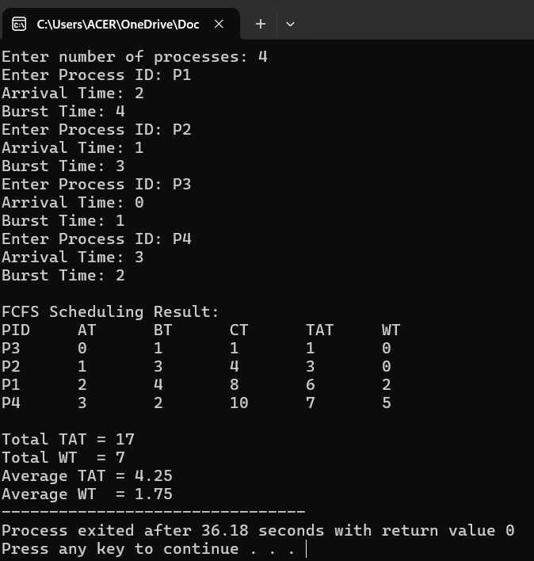

- Assignment Question: Implement SJF (Shortest Job First) Scheduling Algorithm
A process is a program in execution. CPU scheduling determines which process gets the CPU next.
The Shortest Job First (SJF) algorithm selects the process with the smallest CPU burst time next.
SJF can be:
- Non-preemptive → process runs until completion
- Preemptive (SRTF) → process may be interrupted if a new shorter job arrives
In this assignment, consider Non-preemptive SJF.

Problem Statement
Given the following processes:
Process | Arrival Time | CPU Burst Time
P1 | 0 | 8
P2 | 1 | 4
P3 | 2 | 9
P4 | 3 | 5
Task:
Implement the Non-Preemptive SJF Scheduling Algorithm to calculate:
- Completion Time (CT)
- Waiting Time (WT)
- Turnaround Time (TAT)
- Average Waiting Time
- Average Turnaround Time
- Gantt Chart
Program :
#include <bits/stdc++.h>
using namespace std;

struct Process {
string pid;
int at;
int bt;
int ct = 0;
int tat = 0;
int wt = 0;
bool done = false;
};

int main() {
ios::sync_with_stdio(false);
cin.tie(nullptr);

int n;
cout << "Enter number of processes: ";
if (!(cin >> n)) return 0;

vector<Process> p(n);
for (int i = 0; i < n; ++i) {
cout << "Enter Process ID ArrivalTime BurstTime: ";
cin >> p[i].pid >> p[i].at >> p[i].bt;
}

int completed = 0;
int current_time = 0;
long long totalTAT = 0, totalWT = 0;
vector<pair<int,string>> gantt; // (start_time, pid)

// If you want deterministic tie-break: by arrival time then by PID lexicographically.
while (completed < n) {
// find all available (arrived and not done)
int idx = -1;
int min_bt = INT_MAX;
for (int i = 0; i < n; ++i) {
if (!p[i].done && p[i].at <= current_time) {
if (p[i].bt < min_bt) {
min_bt = p[i].bt;
idx = i;
} else if (p[i].bt == min_bt) {
// tie-breaker: earlier arrival time, then lexicographic PID
if (p[i].at < p[idx].at) idx = i;
else if (p[i].at == p[idx].at && p[i].pid < p[idx].pid) idx = i;
}
}
}
if (idx == -1) {
// CPU idle: jump to next earliest arrival
int next_at = INT_MAX;
for (int i = 0; i < n; ++i) if (!p[i].done) next_at = min(next_at, p[i].at);
// record idle period (optional) - we'll just move time forward
current_time = max(current_time, next_at);
continue;
}
// schedule p[idx]
gantt.emplace_back(current_time, p[idx].pid);
current_time += p[idx].bt;
p[idx].ct = current_time;
p[idx].tat = p[idx].ct - p[idx].at;
p[idx].wt = p[idx].tat - p[idx].bt;
p[idx].done = true;
completed++;
totalTAT += p[idx].tat;
totalWT += p[idx].wt;
}
// Output table
cout << "\nPID\tAT\tBT\tCT\tTAT\tWT\n";
for (auto &pr : p) {
cout << pr.pid << "\t" << pr.at << "\t" << pr.bt << "\t"
<< pr.ct << "\t" << pr.tat << "\t" << pr.wt << "\n";
}
cout << "\nTotal TAT = " << totalTAT << "\n";
cout << "Total WT = " << totalWT << "\n";
cout << fixed << setprecision(2);
cout << "Average TAT = " << (double)totalTAT / n << "\n";
cout << "Average WT = " << (double)totalWT / n << "\n";
// Print Gantt chart (simple textual)
cout << "\nGantt Chart:\n";
for (size_t i=0;i<gantt.size();++i) {
cout << " | " << gantt[i].second;
}
cout << " |\n0";
// print end times
for (size_t i=0;i<gantt.size();++i) {
// find the process to get its CT
string id = gantt[i].second;
int ct = 0;
for (auto &pr : p) if (pr.pid == id) { ct = pr.ct; break; }
cout << "\t" << ct;
}
cout << "\n";
return 0;
}
Output :

